Ministerial License Cohort Agreement

In order to develop a life of practice of Reflection and Action (a rule of life)

I commit to the following:

- Thoughtfully read and journal my answers for each chapter
- Faithfully meet, on time, with my cohort once a month for three months
- Engage in the cohort in an authentic manner by the power of the Holy Spirit
- To engage as a full participant, not just as a spectator

The book I have chosen:
Invitations from God by Adele Ahlberg Calhoun

The members of my cohort are: Jeff Randell (PVYFC), Ryan Pramberg (GOYFC), and myself

We have agreed to meet starting May 18th, 2021. We plan to virtually meet weekly and will meet at least twice in person as our schedules allow.

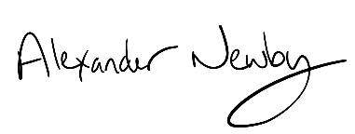

Alexander Newby
5/3/2021

