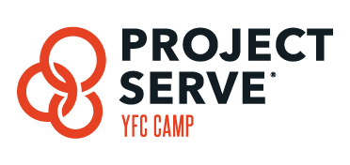

2019 Packing List for Project Serve at Black Diamond

- 2 towels (one for the shower and one for the pool)
- Bedding-sleeping bag or sheet/blanket, pillow
- A watch (cell phones will not be allowed to keep track of time)
- Sunscreen
- Water bottle
- Camera (optional)
- Modest bathing suit – no bikinis
- Comfortable Closed-toe shoes for work
- Casual clothes for working - You are representing Christ to campers. Dress appropriately and clean at all times. No beer t-shirts, spaghetti straps, short shorts, and strapless tank tops, low cut V-neck shirts, etc. Please dress modestly.
- Toiletries
- Bible, Our Daily Bread Devotional, pen
- Money for camp store, vending machines, etc.

If you want to have fun and dress up for special program events at camp during the week, you can bring some of these things too:

- 1 outfit of dark/all black clothes that can get wet (including shoes)
- 1 outfit that can be ruined (including shoes)
- A T-Shirt or Jersey that reps your favorite team
- 1 Neon Outfit

How to Pack & Label Medications –
- ALL MEDS (prescription and over the counter) will be turned in to the camp infirmary.
  - Exceptions to this rule are inhalers & epi-pens. However, these MUST be listed on your CampDoc Profile and approved with the on-site medical staff
- How to pack medications –
  - All meds (prescription and OTC) should come in their original pharmacy container with patient name and dosage info listed
  - Label all meds with camper name and YFC ministry center name
  - Parents, make sure all administration instructions are clearly written on your child’s CampDoc Profile describing all details of dosing and administering of the medications as well as any drug interactions you are aware of with your child’s prescription (i.e. with food, w/o food, time of day, things to consider, etc). This information helps to ensure accuracy and that nothing gets missed). You can print the “Medication Administration Form” from your child’s CampDoc profile to include with their medications for the best clarity.
  - Place all the above into a plastic Ziploc bag for camper to turn into camp infirmary

